**Utsav 2016**



DEVELOPED BY

**Punith Bandodekar Ajay Jagadish Akshath K**

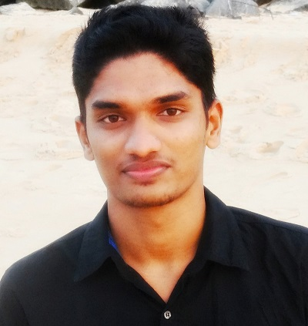 ** 

Under the guidance ofQ

**Mrs. Anuradha Rao**

**Assistant Professor-Senior Scale,**

**Department of Computer Application,**

**M.I.T, Manipal 576104.**

**Introduction**

Utsav is an Annual Inter College Cultural Festival is the flagship cultural event held in the University. Students from all the constituent colleges of the University and also students from our campuses at Bangalore, Sikkim, Nepal, Malaysia and Dubai are invited to participate in this gala event.

Utsav 2016 is an Android application developed for displaying information of the event schedule, venues, images and the results. This app intends to solve the problems of propagating news and information regarding the fest.

There are plenty of advantages associated with Android application development, following 3 are the major ones which should not be overlooked:

* **Ease of Development and Customization:** Android is an open ecosystem where an android app development practitioners can freely access desired sections of the android code they might need for their apps, through the Android Software Development Kit (SDK).
* **Highly Marketable Apps:** No one can deny the fact that Android has the highest smart phone user base. It captures over fifty percent of the global smart phone market. Now with such a vast user base, android apps development emerges potentially profitable deal since one create highly marketable mobile app products which will reach larger group of audiences than it might have on smart phone platforms.
* **No Restriction on Development:** Android application development professional can make his choices to create mobile apps as per revenue models.

**DEVELOPING AN ANDROID APPLICATION**

Android applications are primarily written in the Java programming language. During development the developer creates the Android specific configuration files and writes the application logic in the Java programming language. The Android development tooling converts these application files, transparently to the user, into an Android application. When developers trigger the deployment in their IDE, the whole Android application is compiled, packaged, deployed and started.

**Download Android Studio**

Download Android Studio from the Android Studio website. The download comes in two flavors, SDK Tools only and Android Studio Packages. You want to download the Android Studio Package for your operating system.

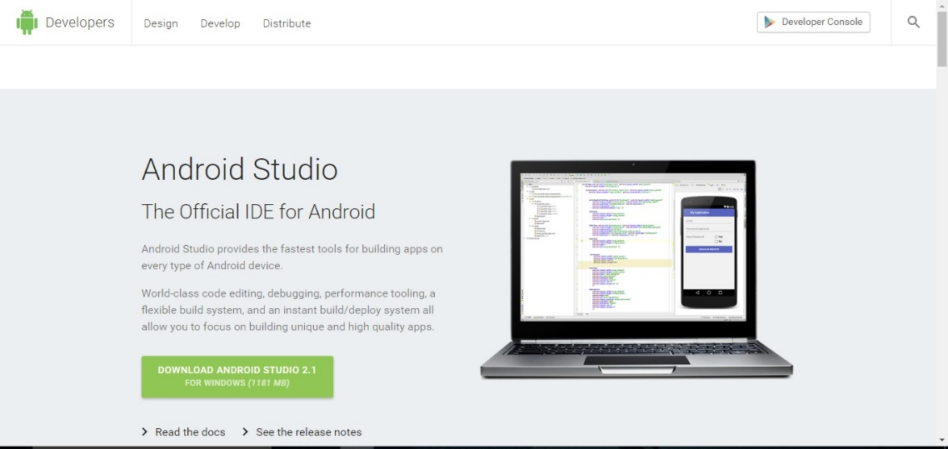

**Android Software Development Kit (SDK)**

The Android SDK (Software Development Kit) is a set of development tools used to develop applications for Android platform. The Android Software Development Kit includes the following:

* Required libraries
* Debugger
* An emulator
* Relevant documentation for the Android Application Program Interfaces (APIs)
* Sample source code

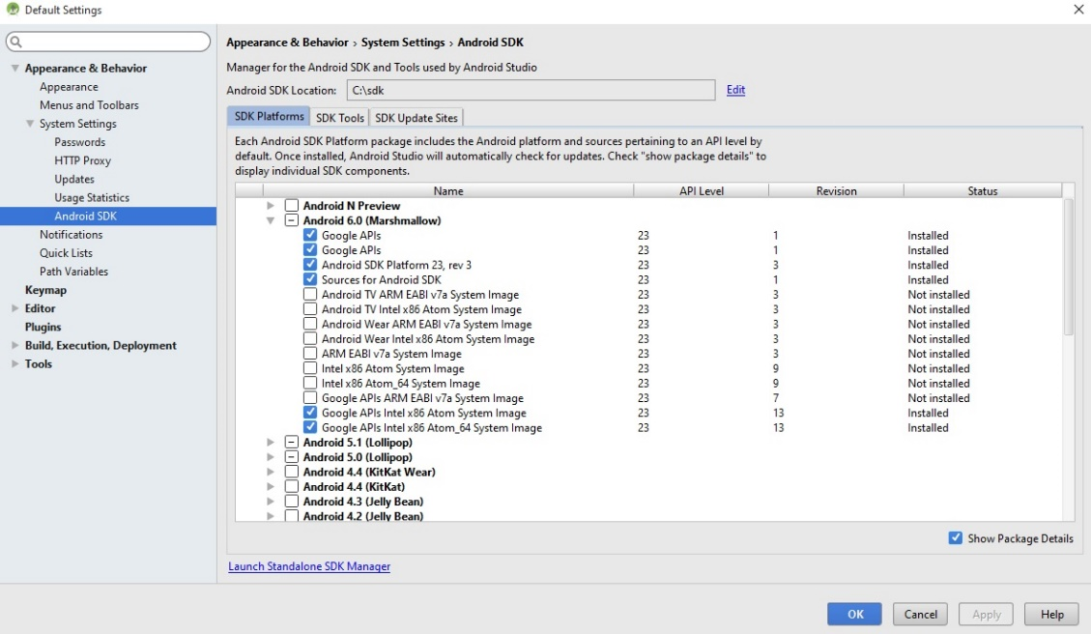

**Objectives:**

* Utsav 2016 Android application provides a medium where one can get the schedule of an event by just opening the application without the internet connection
* Utsav 2016 Android application is used to share information about the events, schedule, venues and contact information of the coordinators of Utsav 2016
* To develop a simple interface for dynamic update of results and images
* To make an easy and instant notification of status, messages and changes in time and venue

**Product Perspective:**

The ”Utsav 2016” app is a new, self-contained product intended for use on the Android platform. The purpose of making this application is to providing easiness of finding the events and schedule at one place. The user will find the Events schedule, venues, result and images in one application rather to visit different web pages. The invention satisfies the foregoing needs and avoids the drawbacks and limitations and frustrations of the prior art, and provides a better, more timely and effective process of communication to view schedule and coordinate events by utilizing this application.

**Project Scope:**

The scope of the project includes creating a user interface to Android system. Utsav 2016 is the application of management to the creation and development of events. The Application generally relates to a system and method to schedule events, and more particularly, to a system and method for scheduling cultural events among entities such as organization that may have limitations for scheduling, such as geographical requirements, constraints by timing, conflicts, availability, or other factors. This Application leads to provide the user especially the student the reliability in finding the schedule of events at one place rather to go for each of the college websites. By this Application the matter of time which goes in informing each other for the event will also be solved out.

**Product Functionality**

The following list offers a brief outline and description of the main features and functionalities of this Utsav 2016 app. Utsav 2016 Android app has following functionalities:

**Features:**

* Information about the events, schedules and venues
* Contact information of the event coordinators
* Photo-Gallery showing glimpses of Utsav
* Venue search
* Notifications of event results, alerts and status
* Chart showing the ranking of top 5 institutions

**Project Plan:**

At the beginning of the project, we scheduled meeting time for the group to discuss on the design and implementation of the software and what language to use in writing the software. We had several meetings to this effect. When then developed a time-line for the project when we would be releasing the first version for scrutiny and the estimated time we thought we would use for refactoring. We also pondered on designing a suitable user interface to the project.

The group was then divided that would work on parts of the code. We kept in touch with each other and whenever we had difficulties, we asked each other questions. On some occasions, we had to pretend we were the customer so as to try to figure out some of the things that user would desire, such as the friendliness of the user interface and ease of navigation through the software.

**CHALLENGES WHILE DEVELOPING UTSAV 2016**

* Difficulty in implementing on touch event for recycler view in android
* Implementation of google maps
* Difficulty in styling interfaces
* Display of results in graphical form
* Embedding instant notification within the app

**UPLOADING THE ANDROID APPLICATION TO PLAYSTORE**

Once the development work on an Android application is complete and it has been tested on a wide range of Android devices, the next step is to prepare the application for submission to the Google Play App Store. Before submission can take place, however, the application must be packaged for release and signed with a private key.

After that upload the application package in the Google Play Developer Console.

* Log in the [Google Play Developer Console](https://play.google.com/apps/publish/). **(It Costs around $25)**
* In the **All Applications** tab, click **Add new application** to create a new app.
* In the **Add new application** dialog, select a default language, provide an application title and choose how to proceed.
* In the **APK** tab, upload your application package.
  + In the **APK** tab, click **Upload your first APK to Production**.
  + Click **Browse files**, locate the application package on your file system and click **Open**.
* In the **Store Listing** tab, complete the required fields in the **Product details** form and click **Save**.
* In the **Pricing & Distribution** tab, complete the pricing and distribution settings for your app and click **Save**.
* From the **Ready to publish** drop-down menu, select **Publish this app**.
* Verify that the status of your app is updated to **Published**.

**UPLOADING THE ANDROID APPLICATION TO PLAYSTORE**

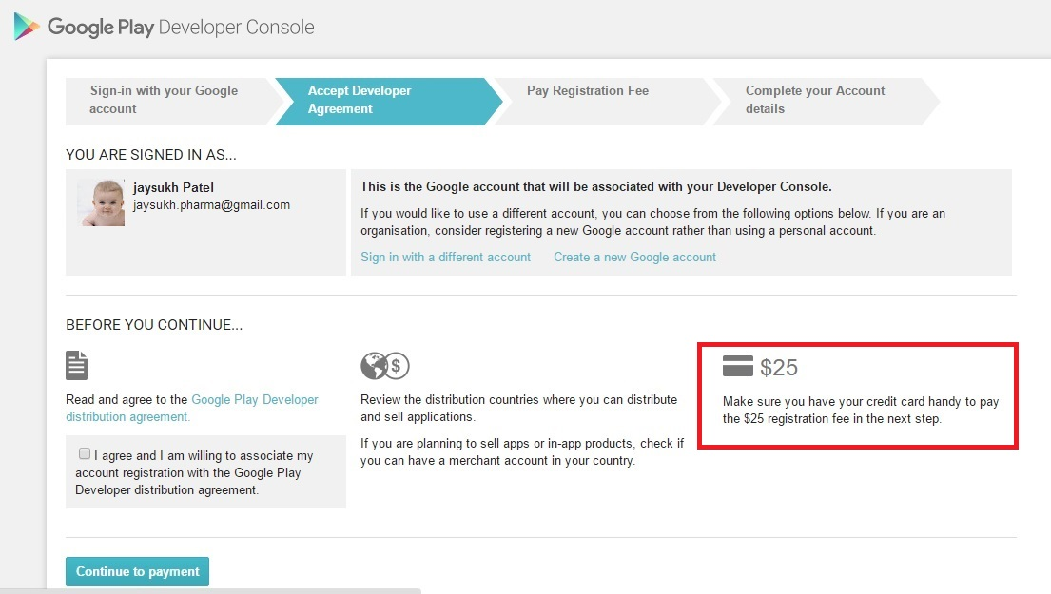

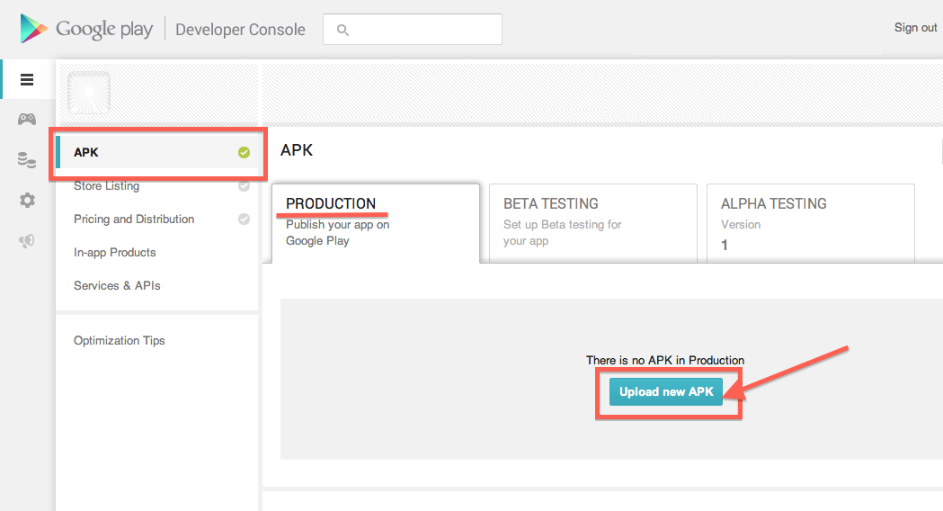

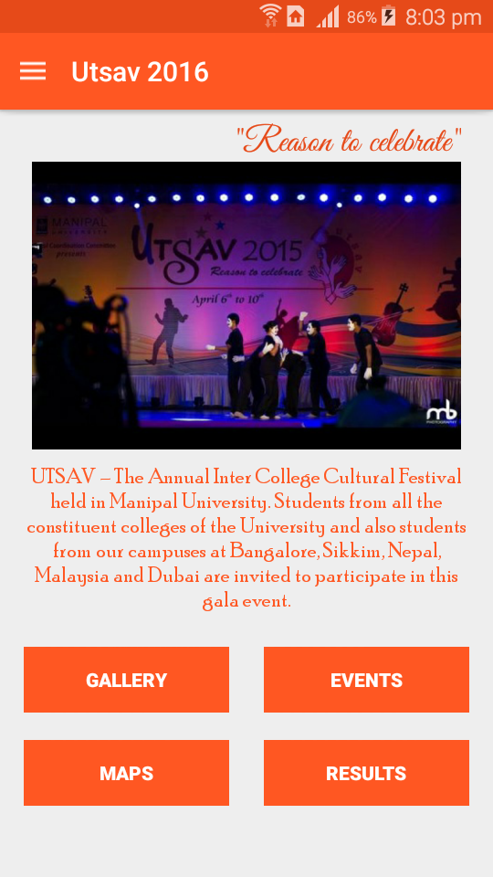**SCREENSHOTS**

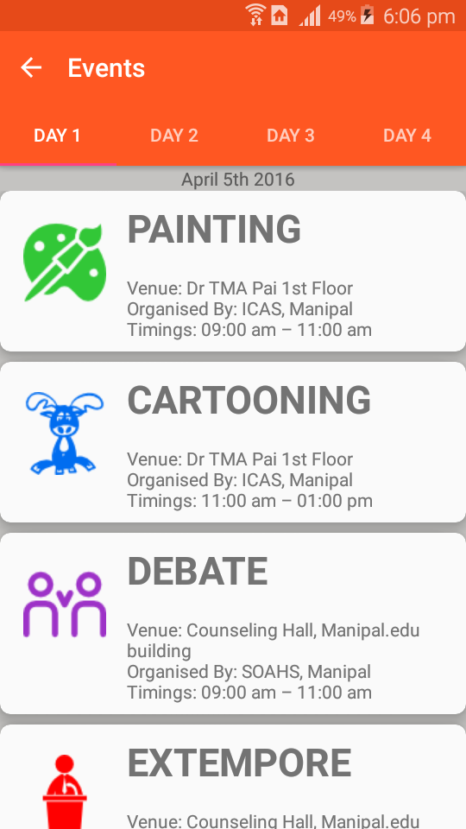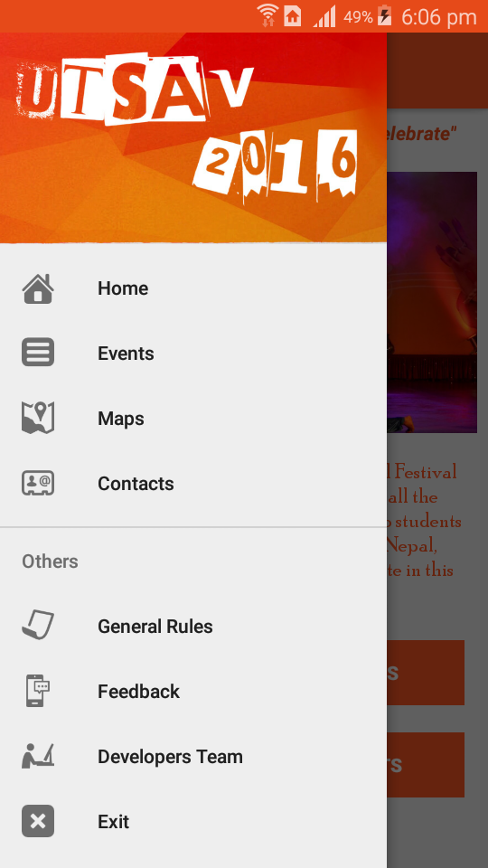

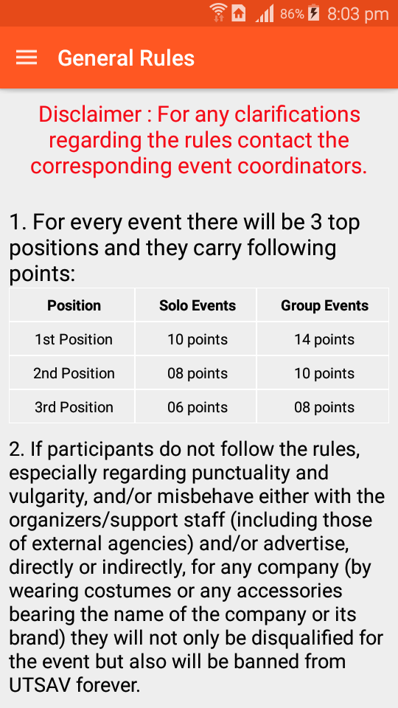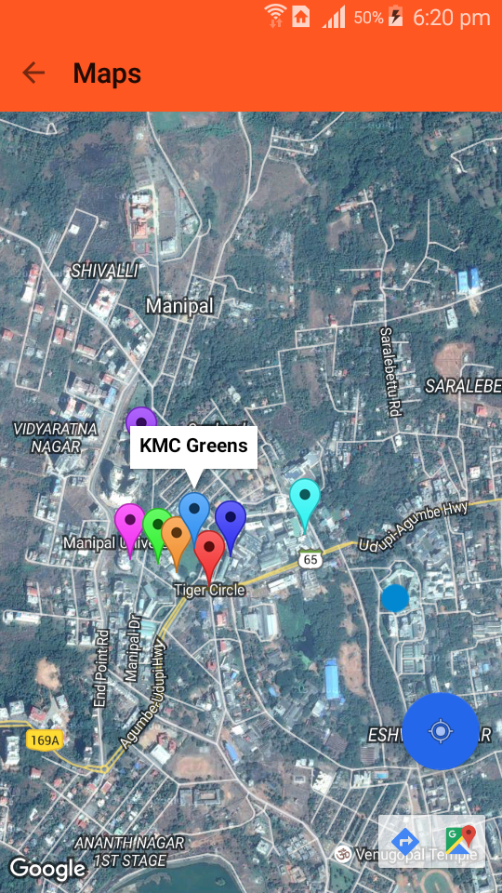

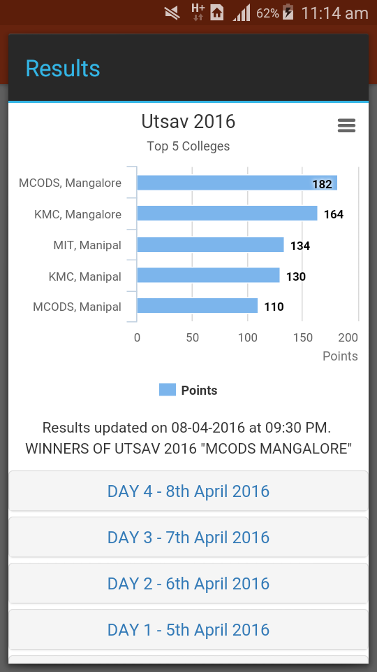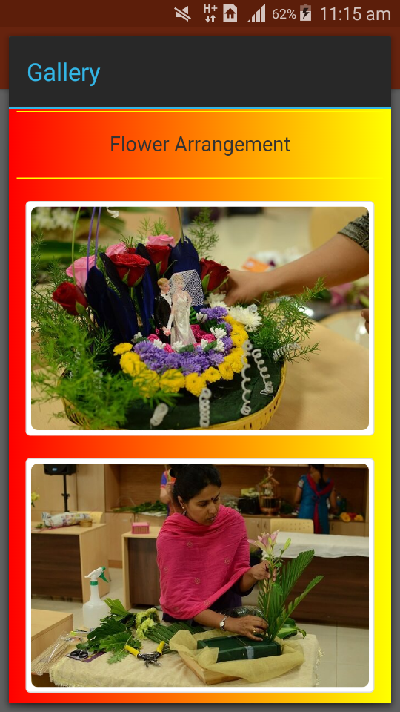

|  |  |
| --- | --- |
| **Date** | **Number of Downloads** |
| **26/03/2016** | **2** |
| **27/03/2016** | **4** |
| **28/03/2016** | **3** |
| **29/03/2016** | **16** |
| **30/03/2016** | **58** |
| **31/03/2016** | **24** |
| **01/04/2016** | **69** |
| **02/04/2016** | **53** |
| **03/04/2016** | **50** |
| **04/04/2016** | **73** |
| **05/04/2016** | **59** |
| **06/04/2016** | **57** |
| **07/04/2016** | **87** |
| **08/04/2016** | **51** |
| **Total Downloads till 2016 Utsav fest concluded** | **606** |

**DOWNLOAD STATISTICS**

**Software Uploaded on: 26-03-2016**

**Total Downloads till 09-05-2016**

**658**

**CONCLUSION, ACKNOWLEDGEMENT AND FUTURE WORK**

**CONCLUSION**

This application focuses on solving the problems of propagating events information such as venues, results and images, also developing the application to satisfy user’s desire. Moreover, this application will provide significant information of events in order to be easily reached by users and other details such as venue information, results and images corresponding to the events are made available through this app, additionally this application can be used anywhere, anytime. Future development of this application will also consider the point to make it platform independent.

**ACKNOWLEDGMENT**

The implementation and documentation of this project would not be succeeded without the kind support from individuals. First of all, we would like to express our special gratitude to Mrs Anuradha Rao who always gave us valuable advice and kind assistance to complete this project. Last but not the least, we would like to thank the Cultural Coordination Committee, Manipal University for giving us the great knowledge and support for the successful completion of the app development.

**FUTURE WORK**

Since the trends keep on changing, this application can be customized to make it more user friendly in future.

* The registration for the events in the fest can be done through the app itself.
* The Utsav App can be developed using cross platform app development tools so that it can be used on all the platforms such as Windows, Apple IOS and Android.
* Development of website for the Utsav fest

**Bibliography**

[1] [http://www.androidhive.info/](http://www.androidhive.info/%20) [Last browsed on: 01/05/2016]

[2] [http://stackoverflow.com/](http://stackoverflow.com/%20) [Last browsed on: 01/05/2016]

[3] [http://androidexample.com/](http://androidexample.com/%20) [Last browsed on: 01/05/2016]

[4] [http://www.tutorialspoint.com/android/](http://www.tutorialspoint.com/android/%20) [Last browsed on: 01/05/2016]

[5] [http://www.sanfoundry.com/java-android-programing-examples/](http://www.sanfoundry.com/java-android-programing-examples/%20) [Last browsed on: 01/05/2016]